
Name of the Experiement : Wallet Walkthrough – Hands-on Wallet Setup
Objective/Aim :
To understand and perform the step-by-step installation and setup of a blockchain wallet, enablinginteraction with Web3 dApps and networks like Ethereum or Polygon.
Apparatus/Software Used:
- Desktop or mobile device with internet
- Web browser (Chrome/Firefox/Brave)
- MetaMask Wallet (most commonly used wallet

Theory/Concept:
A crypto wallet allows users to store, send, and receive cryptocurrencies. In Web3, it also functions as your
digital identity and login method for dApps. Types of wallets:
- Hot Wallets (online, e.g., MetaMask)
- Cold Wallets (offline, hardware wallets)
- Custodial vs Non-Custodial (control of private keys)

Procedure:

Step 1: Install MetaMask
- Visit: https://metamask.io
- Click “Download”
- Choose your browser or mobile platform
- Add the MetaMask extension

.

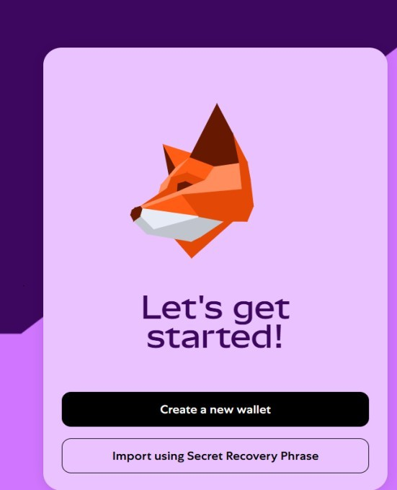

Step 2: Create a New Wallet
- Click “Get Started”
- Select “Create a Wallet”
- Set a strong password (store securely)
- Read and accept terms

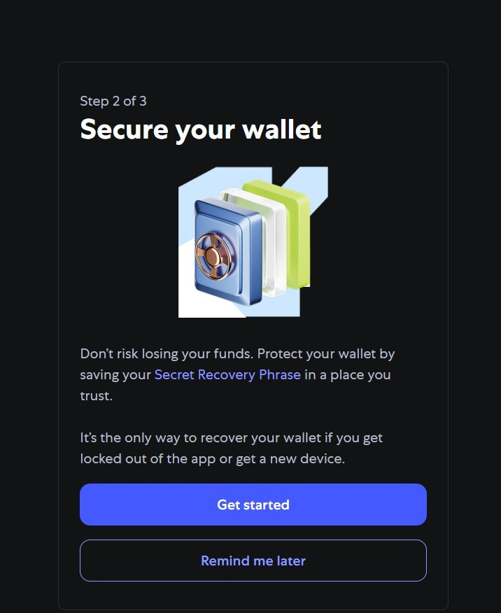

Step 3: Secure Your Wallet
- Write down the 12-word Secret Recovery Phrase on paper (do not store online)
- This phrase is the ONLY way to recover your wallet
- Confirm the phrase when prompted

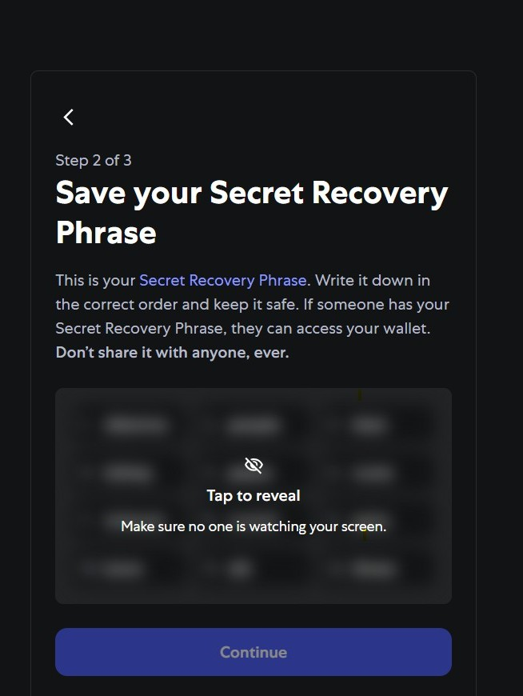

Step 4: Explore Your Wallet
- You'll see your Ethereum address (starts with 0x...)
- Check balance, transaction history, and add custom tokens
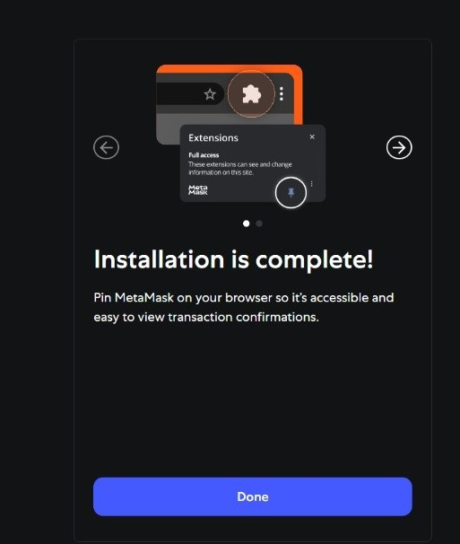

Step 5: Connect to a dApp (optional)
- Visit a dApp like Remix or Uniswap
- Click “Connect Wallet”
- Authorize MetaMask connection

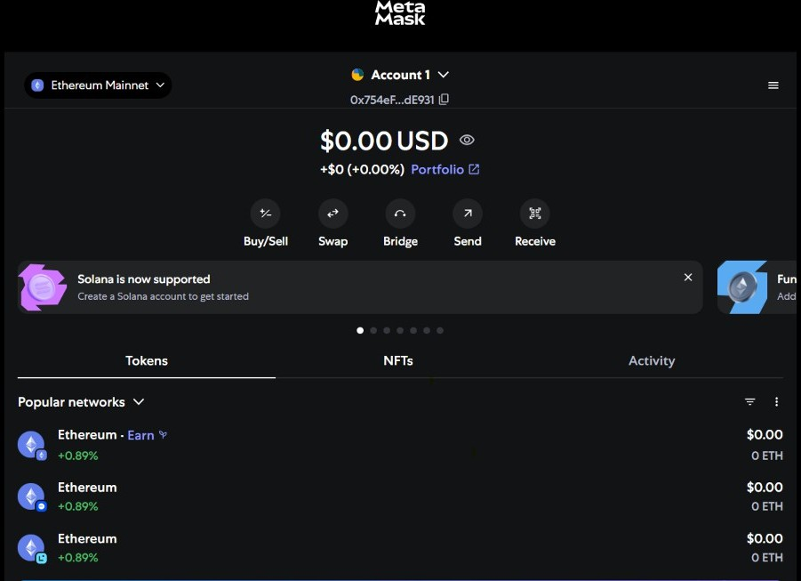
Observation:

- During the hands-on wallet setup, it was observed that the 12-word Secret Recovery Phrase is critically important for wallet recovery.
- If the user forgets or loses the recovery phrase, it is not possible to recover the wallet or access the stored funds.
- Wallet providers like MetaMask do not store the recovery phrase; therefore, the responsibility of securing it lies entirely with the user.

